**Steps to invoke MultiConfig Job manually for all error out models:**

Load CTO API tester with the below url:

**Services to be invoked at CTO end :**

**API tester url :**

[**http://g1t7196.austin.hpicorp.net:9080/smcfs/yfshttpapi/yantrahttpapitester.jsp**](http://g1t7196.austin.hpicorp.net:9080/smcfs/yfshttpapi/yantrahttpapitester.jsp)

**Or**

[**http://g2t5179.austin.hpicorp.net:9080/smcfs/yfshttpapi/yantrahttpapitester.jsp**](http://g2t5179.austin.hpicorp.net:9080/smcfs/yfshttpapi/yantrahttpapitester.jsp)

**Service 1: To load all possible combination in CTO database**

**Service Name:** HPSEMMultiConfigCTOService

**Input: [varies based on model]**

<Model Country="US" Currency="USD" Language="en" OrganizationCode="US_Store" Path="US_005FStore/Sandbox/QA/Laptops/D9S33AV"/>

* Click “Test API Now” after giving input
* Response will be as below

<?xml version="1.0" encoding="UTF-8"?>

<APiMultiConfig Message="324 Valid configuration found for this model"/>

[no of combination varies based on model]

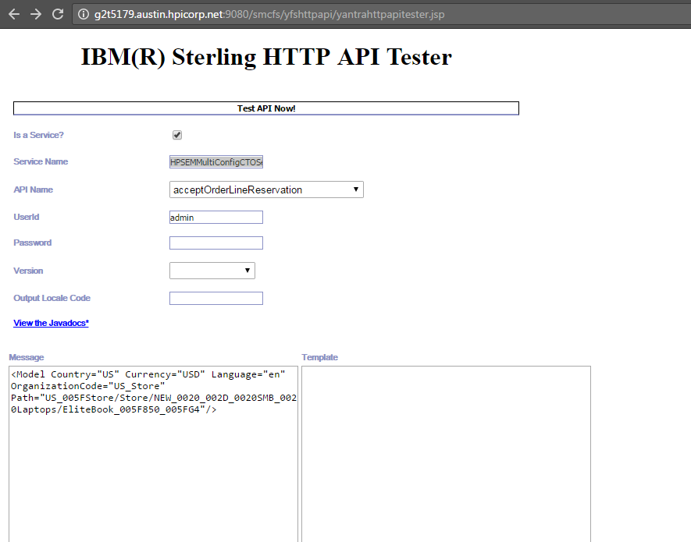

**Service 2:  To process the combination to update price and catalog [Invoke it only once after invoking 1st service for all the models]**

**Service Name:** HPItemPriceCTOService

**Input:**

<Model Country="US" Currency="USD" Language="en" OrganizationCode="US_Store" Path="US_005FStore/Sandbox/QA/Laptops/D9S33AV"/>

* Click “Test API Now” after giving input
* It will end with the below response.

<ApiSuccess/>

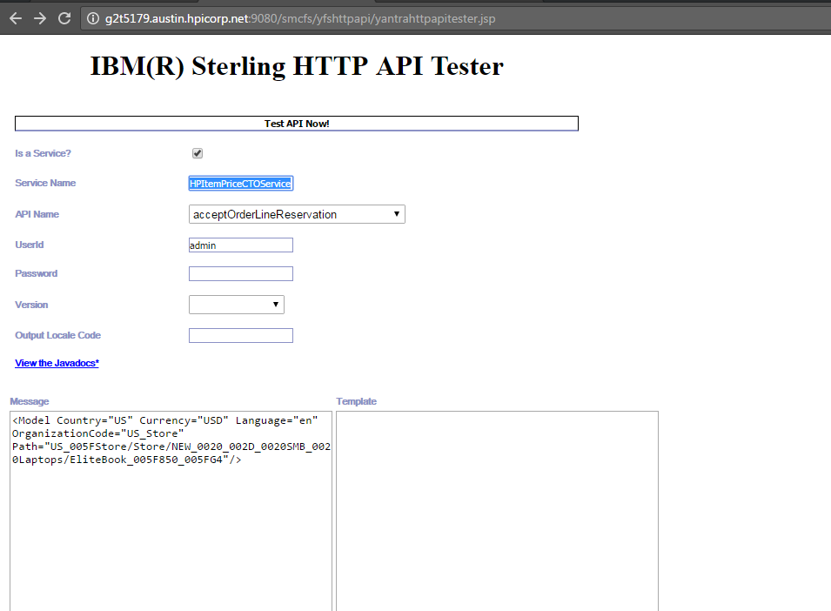

**Note:**

* Don’t do parallel invocation. Models needs to be processed one after the another.
* Ensure there is no results for the below query in CTO database at the end before proceeding with Lowest price job.

Select * from hp_sem_multiconfig where total_price is null.